FUGE camp registration June 27th- July 2rd (Monday- Saturday)
Total cost $282.00:
Need to know who is planning on going by January 24th!
*cost 50.00 deposit due by January 30th or work spaghetti dinner on January 30th from 5:30 – 7.
* I need to know total of those wanting to go by January 24th
* It is non-refundable
* We are going to North Greenville South Carolina
* On our extra-long FREE Day, usually Wednesday, we will be going white water rafting. This is an additional cost and is not part of FUGE camp. (about $25-$30 per person)
Tracks:
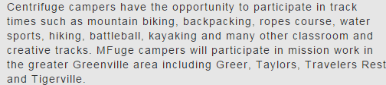
Housing: (2 people in one room with 2 another: joining with a bathroom) Notice it says most rooms.
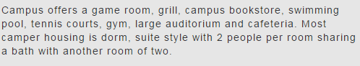
Click on link for room descriptions: (Rooms were listed with air conditioner)
http://www.ngu.edu/facilities.php
