FUGE camp registration June 21th- June 26th (Monday- Saturday)
* We are going to North Greenville South Carolina
* On our extra-long FREE Day, usually Wednesday, we will be going white water rafting. PLEASE SIGN THE WAIVER FORM!
Tracks:
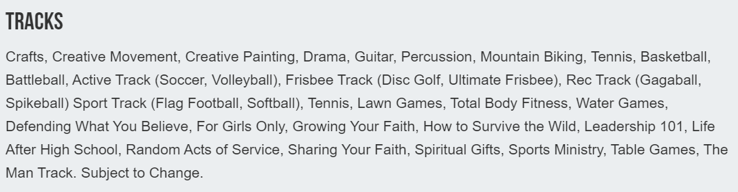
Housing: (2 people in one room with 2 another: joining with a bathroom) Notice it says most rooms.
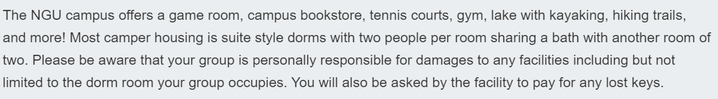
Click on link for room descriptions: (Rooms were listed with air conditioner)
http://www.ngu.edu/facilities.php
